Chapter 13, Solution 87.

Z_{Th} = Z_{L}/n² or n = 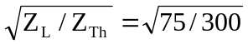 = 0.5

